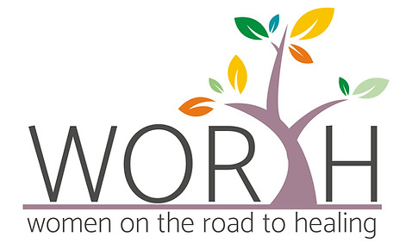 Client Referral Form
Name:
Address:
Date of Birth:
Contact Numbers (s):
Email:

Referred from:
- Elm Foundation
- Self-Referral
- Church (please tell us which Church)
- Police
- Other (please give us more information)

Name of referrer/ point of contact:

We understand that faith plays an important part in healing. To enable us to support you more appropriately, please answer the following questions:
Are you part of a faith community? YES / NO / RATHER NOT SAY
If yes, please tell us which one

FOR THE REFERRER – PLEASE GIVE US ANY ADDITIONAL INFORMATION ABOUT THE CLIENT

PLEASE RETURN TO CONTACT@WORTH-CHARITY.CO.UK

